Interview

Functional

1. What information should be collected when creating an account

-

2. What type of accounts should the costumer be able to open

-They should be able to open or have an option to open the savings account, investment account and the cheque

3. How should the system handle interest

-The system must calculate the interest rate monthly, 0.0025% for the savings account, 0.75% for organisations and 5% for the investment account

4.

5.

Non-functional

1.

2.

3.

4.

5.

Use case diagram

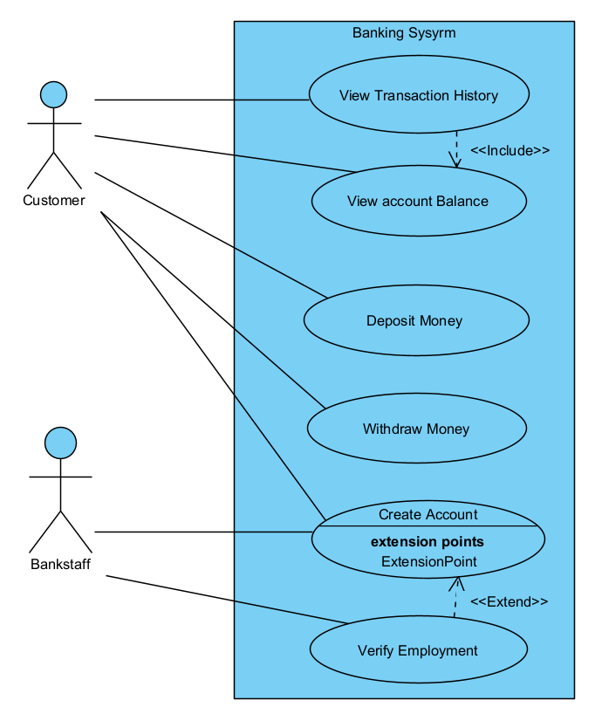

Class diagram

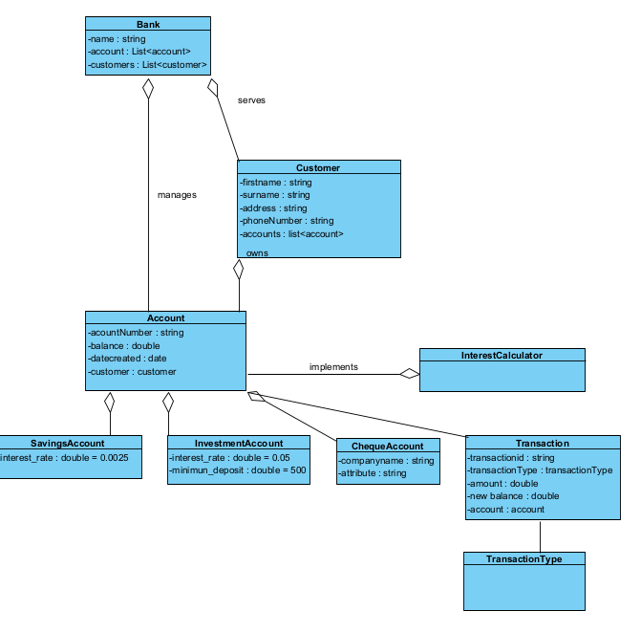

Account creation sequence diagram

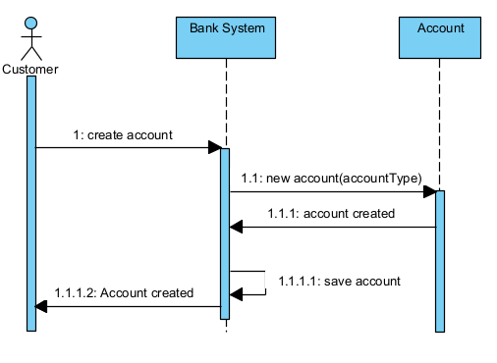

Deposit sequence diagram

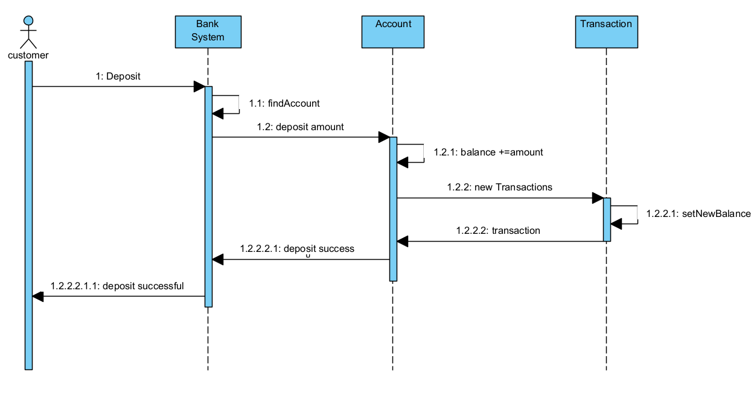

State diagram

